The instruction of running Eye Tracker Software:

1. Download and install Tobii software from the following link: <http://developer.tobii.com/eyex-setup/>

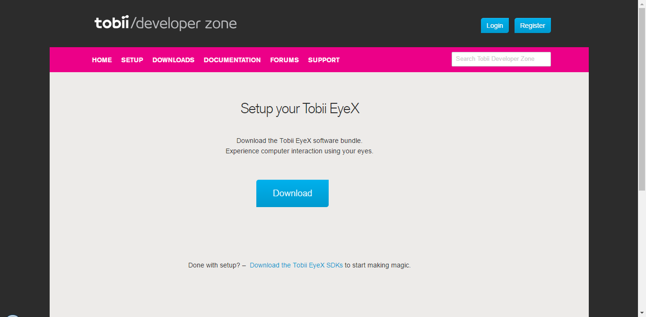

1. Download and install the visual studio software from the following link: <https://www.visualstudio.com/post-download-vs/?sku=ent&clcid=0x409&telem=ga#>

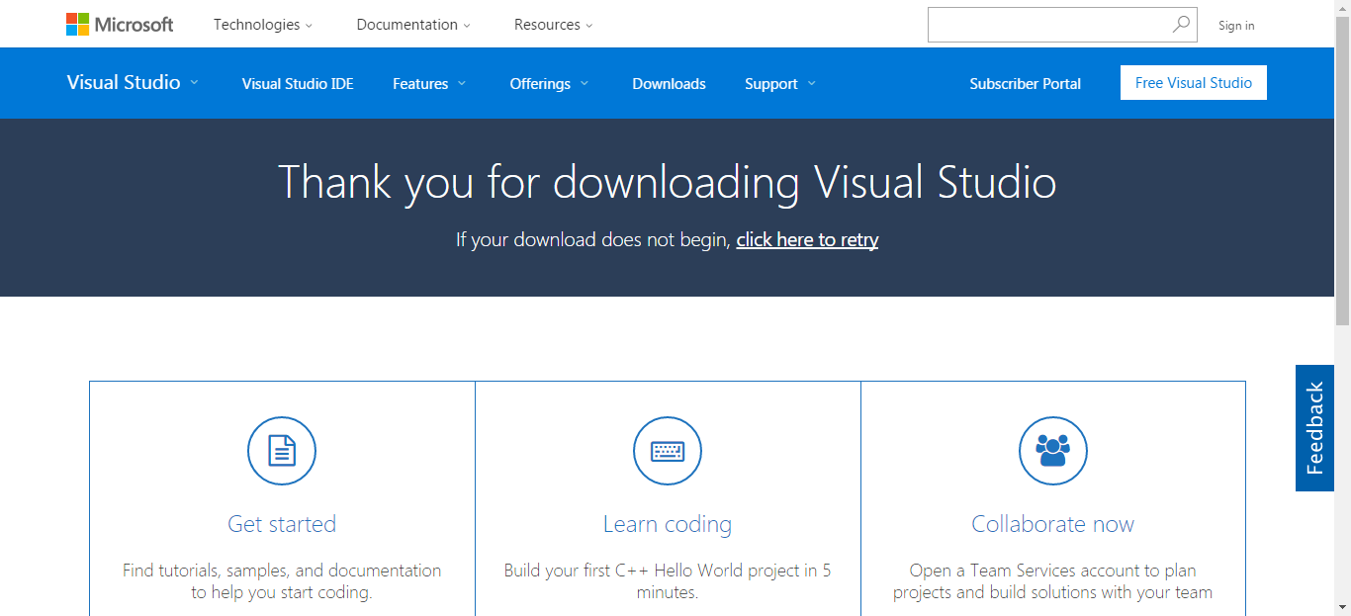

1. Connect Tobii eye tracker to USB 3.0 of your computer

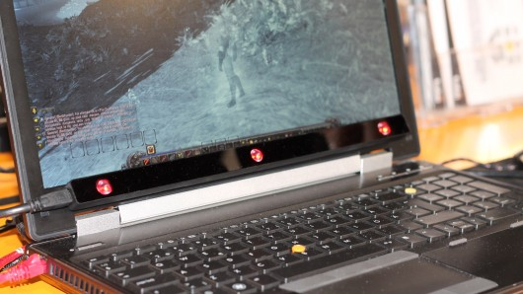

1. Open visual studio solution (C:\Users\Zeus\Documents\GitHub\StepCounter1\StepCounter\Suhas - Main Project\source\EyeXDotNet.sln)

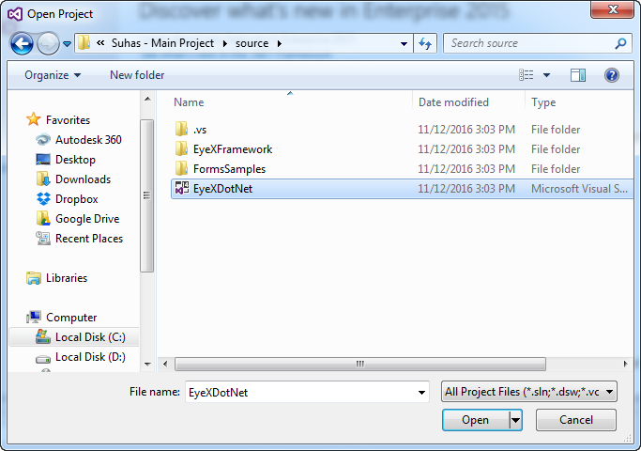

1. Calibrate your eyes using tobii software.
2. In the visual studio software click on start button

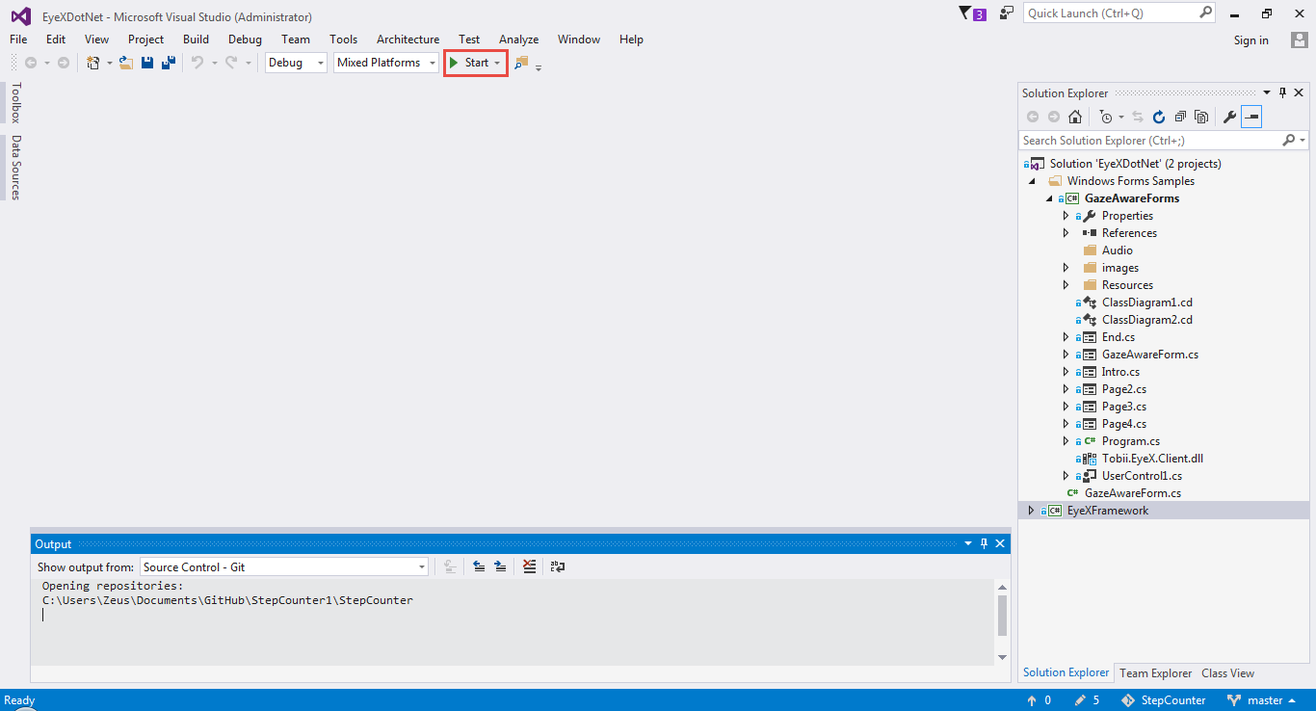

Click

1. Enjoy the demo